**The Human Heart**

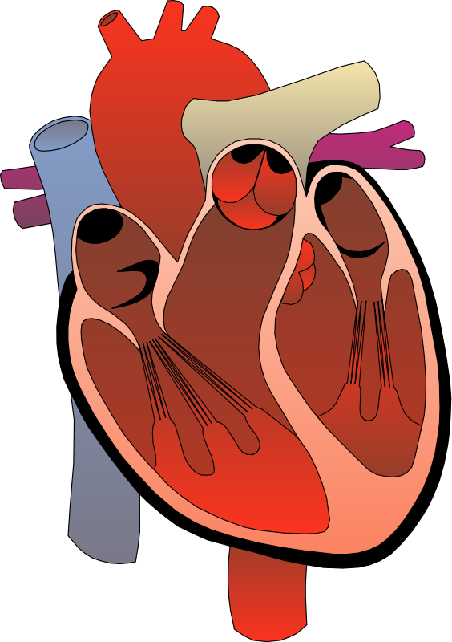

Table of Contents

**1.** **About:-** 3

**2. Exterioir parts of the heart:-** 3

**i.** **Aorta:-** 3

**II.** **Superior vena cava:-** 4

**III.** **Left Pulmanary veins:-** 4

**IV.** **Left Pulmanary veins:-** 4

# **About:-**

The human heart is an organ that pumps blood throughout the body via the circulatory system, supplying oxygen and nutrients to the tissues and removing carbon dioxide and other wastes.

* The four main functions of the heart are:-
* Pumping oxygenated blood to the other body parts.
* Pumping hormones and other vital substances into different parts of the body.
* Receiving deoxygenated blood and carrying metabolic waste products from the body and pumping it to the lungs for oxygenation.
* Maintaining blood pressure.

# **2. Exterioir parts of the heart:-**

## **Aorta:-**

The aorta is the largest artery in the body. The aorta begins at the top of the [left ventricle](https://www.medicinenet.com/image-collection/heart_detail_picture/picture.htm), the heart's muscular pumping chamber. The heart pumps blood from the left ventricle into the aorta through the [aortic valve](https://www.medicinenet.com/heart_disease_pictures_slideshow_visual_guide/article.htm). Three leaflets on the [aortic](https://www.medicinenet.com/heart_disease_pictures_slideshow_visual_guide/article.htm) valve open and close with each heartbeat to allow one-way flow of blood.

The aorta is a tube about a foot long and just over an inch in diameter. The aorta is divided into four sections:

* The [ascending aorta](https://www.medicinenet.com/heart_disease_pictures_slideshow_visual_guide/article.htm) arises
* The aortic arch curves over the heart
* The descending thoracic aorta
* The abdominal aorta

## **II. Superior vena cava:-**

The superior vena cava is very important for the function of the cardiovascular system since it largely contributes to the input of blood to the right atrium. Any hypertensive process in the right half of the heart or the pulmonary circulation retrogradely affects both superior and inferior venae cavae. This is important since the veins are not adjusted to high pressures, which can result in forming an aneurysm or even rupture of the wall of the SVC.

## **III. Left Pulmonary veins:-**

There are four pulmonary veins in the human body, all of which bind to the left atrium of the heart. The pulmonary arteries carry oxygen-depleted blood from the heart to the lungs. The blood returns to the heart through the pulmonary veins until it has been oxygenated. The heart then pumps freshly oxygenated blood throughout the body. Pulmonary veins differ from other veins in the body in that they transport deoxygenated blood back to the heart from the rest of the body. The left pulmonary veins bind to the left lung, and the lungs are made up of hollow air sacs known as alveoli. This is the process of removing oxygen from inhaled air. This also serves as a gas exchange system.

## **IV. Inferior vena cava :-**

At the level of the fifth lumbar vertebra, just below the small of the back, the two main veins from the legs, the common iliac veins, come together to form it. It has a large number of tributaries between its point of origin and its heart terminus, unlike the superior vena cava veins that absorb blood from the loins' muscles and coverings, as well as the walls of the belly, the sexual organs, the kidneys, and the liver, are among them. The inferior vena cava ascends close to the backbone on its way to the heart. It passes through the liver, forming a groove on the dorsal side, reaches the chest through a diaphragm opening, and empties into the right atrium of the heart through a non-valve opening below the point of entry for the superior vena cava.